Western blot buffers

Western Lysis Buffer

IPN150
- 50mM Tris/HCl pH 7.6
- 150mM NaCl
- 5mM MgCl2
- 0.1% NP40
add fresh:
- 1x protease inhibitor (Sigma)
- 1mM DTT
- Benzamidine (1mM)
If analyzing phosphorylation:
- 1:100 Phosphatase Inhibitor Cocktail 2 (Sigma)
- 1:100 Phosphatase Inhibitor Cocktail 3 (Sigma)

10x Transfer buffer
For 1000ml
- 30g Tris base
- 144g Glycin
- H20

1x Transfer buffer
- 100ml 10x transfer buffer
- 700ml H20
- 200ml Methanol

10x TBS
- 24.3g Tris base
- 88g Nacl
- 1000ml H20
- adjust pH to 7.6

1x TBS-T
- 100ml 10x TBS
- 900ml H20
- 1ml Tween 20

Protein Lysis
- Prepare lysis buffer (see Buffers)
- Pellet cells and resuspend in Lysis Buffer
- Keep on ice for 30 minutes
- Spin at 16000 g for 10 min at 4°C
- Transfer supernatant into new tube
- freeze at -80°C

Protein quantification with BCA assay

Prepare protein standard
- Use a 96-well flat bottom plate
- Add 184 ul H20 to the first well of the first two columns.
- Add 100 ul H20 to the remaining wells of the first two columns
- Add 16 ul BSA (2 mg/ml) to the first well of each column and then do a 1:2 dilution by transferring 100ul down the column,
- Standard curve: 16ug, 8ug, 4ug, 2ug, 1ug, 0.5ug, 0.25ug, and 0ug

Prepare samples
- If expecting high protein concentration: Add 2 ul sample to 98ul H20.
- If expecting lower protein concentration: Add 5 ul sample to 95ul H20.

BCA Assay
- Mix reagent A to B in 50:1 mixture.
- Add 100ul to each well.
- Incubate at 37°C for 10-15 min
- Read plate at 560nm

Run Western Blot

Prepare sample
- total volume depends on the gel usually between 15 and 20ul can be loaded
- for 20ul
  - 5ul 4x loading dye
  - 2ul 10x reducing agent
  - 13ul sample
    - keep ug protein between the samples consistent, fill with lysis buffer
- heat at 70°C for 10min
- spin down shortly
- keep on ice

Load and Run gel
- Gel used: Bis-Tris NuPage 4-12%
- prepare MES running buffer by diluting the 20x stock
- fill chamber with running buffer
- load 8ul PageRuler™ Plus Prestained Protein Ladder
- load samples
- add 500ul Antioxidant to the inner chamber
- run at 120V until desired location

Transfer
- soak membrane in methanol for 30s
- soak membrane in transfer buffer > 2min
- prepare transfer cassette (see image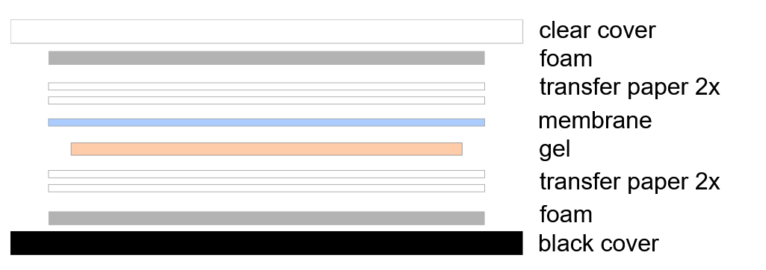
- make sure all bubbles are removed between gel and membrane
- fill with transfer buffer
- add ice pack into chamber
- run at 70V for 90min at 4°C

Blocking
- Block membrane in TBS-T + 5% BSA (or milk powder) for 1h at room temperature
- wash 3x with TBS-T for 5 min each.

Staining
- stain with primary Ab in TBS-T + 5% BSA over night at 4°C
- wash three times
- add secondary antibody TBS-T + 5% BSA, incubate for 1 hour at room temperature
- wash at least three times

Developing
I used Amersham™ ECL™ Prime Western Blotting Detection Reagent
- Mix solutions A and B at 1:1, if primary ab is strong, can add PBS to dilute
- Drain excess wash buffer from the washed membrane and place it protein side up in a suitable box or on a sheet of plastic sheet protecter or other suitable clean surface. Add detection reagent onto the membrane and make sure it completely covers the membrane
- Incubate for 45sec at room temperature
- Drain off excess detection reagent by holding the membrane edge gently against a tissue

